
Official league roster – Basketball 2025-26
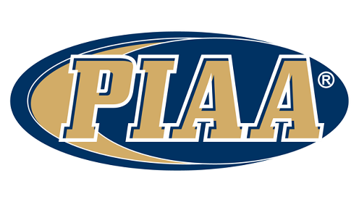
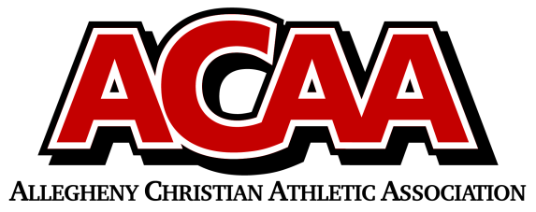

School Name: Meadowbrook Christian
Team Colors: Forest Green / White
Overall Wins ___ Losses ____ Ties ___
ACAA Wins ___ Losses ____ Ties ___ OPPONENT: __________________________
Date: _________
Number | Name | Year | Position | Height | Homeschool
25 | Jaeden Canelo | 10th
31 | Alex Clark | 11th
1 | Josiah Cruz | 11th
4 | Evan Peachey | 11th
24 | Isaac Beltz | 10th
2 | Gavin Canelo | 10th
15 | Malachi Dick | 10th
3 | Ryan Eager | 10th
30 | Grant Moore | 10th
45 | Taylor Clark | 9th
41 | Owen Crisswell | 9th
11 | Gio Custodio | 9th
12 | Luke Fasnacht | 9th
35 | Eli Koch | 9th
40 | Griffin Runkle | 9th

VARSITY/JV Boys
Head Coach: Collin Erb
Asst. coach/JV: Ray Randall
Asst. coach: HENRY CANELO, Jordan Martin, Matt Koch
Statistician: Mike Locke
Athletic Director: Samantha Erb

Official ACAA League Team Roster. to be submitted to the scorer’s table before each game.

